Project Activity Report-6

Project Title: “Build a GNU/Linux Distribution”

Team members: Faculty Guide:

Arpan Chavda (09bce006) Dr. Sanjay Garg

Hitesh Piprotar (09bce054) Computer Sci. & Engg. Department



Duration: 1/4/2013 to 16/4/2013

* This time, We are focusing on the development of some basic utilites that are going to be develop to enhance operating system experience.

**LIST OF UTILITIES**

1. Auto ON Utility:  
     
   This application is developed with the aim of booting up PC at given time from shut down. This software is developed for Linux systems not for windows.

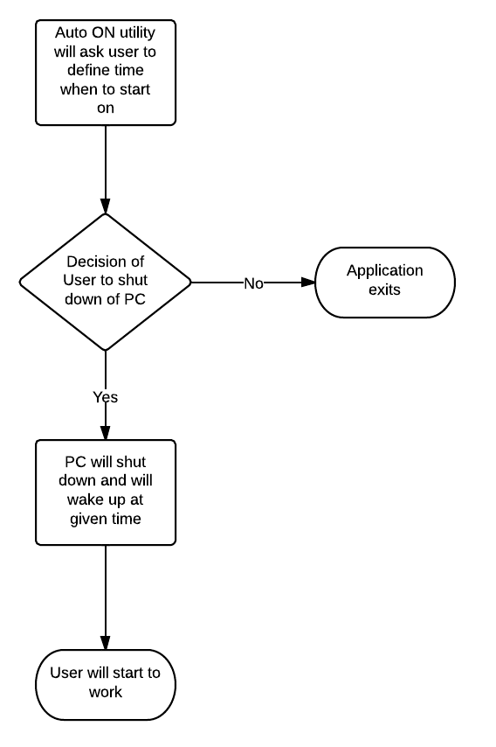

Code repository: <https://github.com/arpan-chavda/autoon-util>

1. LAMP(Front end)  
     
   This application is developed with the aim to handle LAMP Services(Apache, MySQL and PHP Services installed inside Linux system)

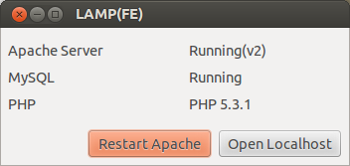

Figure :LAMP Screenshot

1. Multidoc Converter  
     
   This application is developed with aim to convert multiple document formats between each other.

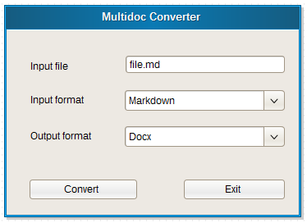

1. Repocloner

**Source Code Repositories**

* Auto ON Utility (<https://github.com/arpan-chavda/autoon-util>)
* LAMP Front end (<https://github.com/arpan-chavda/lamp-fe-linux>)
* Multidoc Converter (<https://github.com/arpan-chavda/multidocconverter>)
* Repocloner (<https://github.com/arpan-chavda/repocloner>)